HEALTHCARE MANAGEMENT: PATIENT READMISSION PREDICTION
Capstone Project Report
Submitted By: Pragya Raghuwanshi

Excel
Task 1: Data Exploration
The healthcare dataset contains 101,766 patient records with complete information for key numerical features. Patients stayed in the hospital for an average of 4.4 days, underwent approximately 43 lab procedures, received 16 medications, and had around 7 diagnoses per encounter. The analysis indicates significant variation in patient treatment patterns, highlighting the complexity of healthcare services and providing valuable insights for understanding factors that may influence patient readmission.
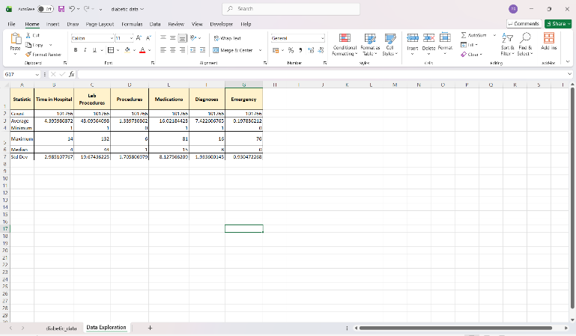
Task 2: Number of Readmissions by Gender and Age Group
The analysis shows that the majority of patient encounters did not result in readmission. Female patients recorded slightly higher readmission counts than male patients. Readmissions were most common among patients aged 60–80 years, indicating that older age groups are more likely to experience hospital readmission. These insights can help healthcare providers focus on high-risk patient segments and improve post-discharge care strategies.
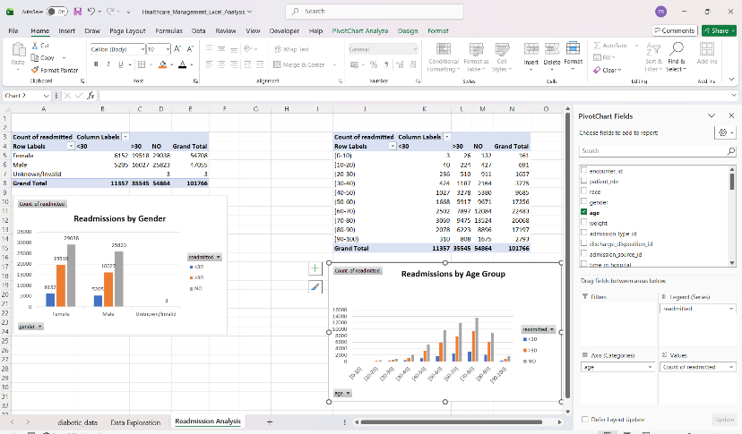

Task 3: Show Race Distribution in a Chart
The patient population is predominantly Caucasian (75%), followed by African American (19%) patients. Hispanic, Asian, Other, and Unknown racial groups represent a relatively small proportion of the dataset. This distribution provides insight into the demographic composition of the healthcare population and can support demographic-based healthcare analysis.
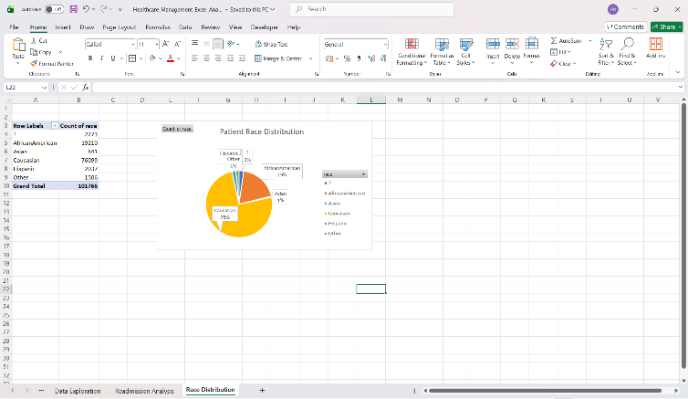

Task 4: Plot Count of Patients for Each Readmitted Category
The majority of patient encounters (54,864) did not result in readmission, indicating successful treatment outcomes for most patients. However, a significant number of patients (35,545) were readmitted after 30 days, while 11,357 patients were readmitted within 30 days. These findings highlight the importance of identifying high-risk patients and implementing preventive healthcare strategies to reduce readmission rates.
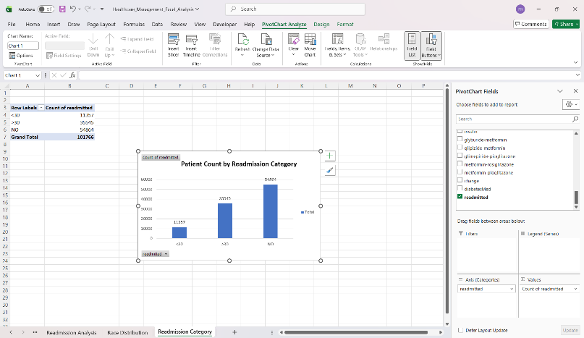
SQL
Task 1: Calculate the Total Number of Patient Encounters
The healthcare dataset contains 101,766 patient encounter records, providing a large and comprehensive dataset for analyzing patient demographics, diagnoses, treatment patterns, and hospital readmission behavior.
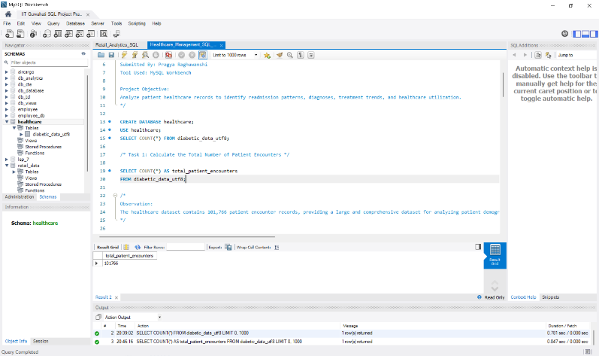
Task 2: Identify the Top 10 Most Frequent Diagnoses
The analysis identifies the most frequently occurring primary diagnoses among patients and highlights the most common medical conditions treated within the healthcare system.
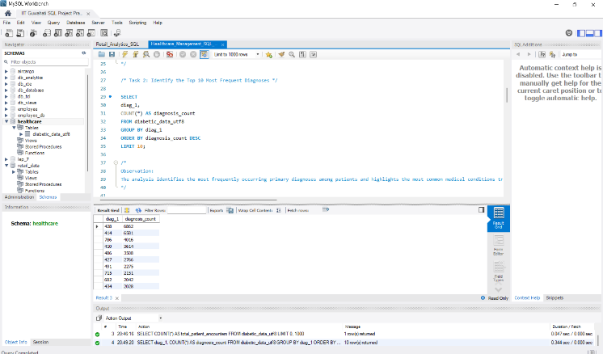
Task 3: Calculate the Average Length of Hospital Stay for Each Admission Type
The average hospital stay varies across admission types, helping identify categories requiring extended treatment and medical attention.
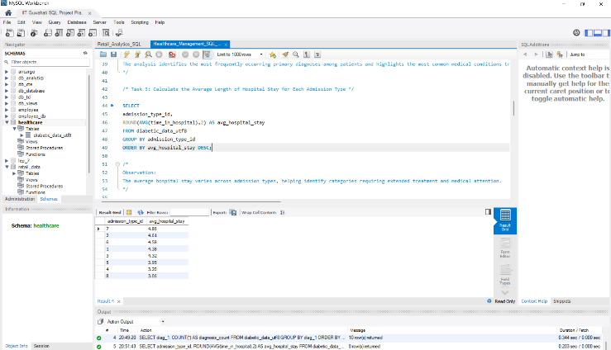
Task 4: Determine the Number of Readmitted Patients and Percentage of Total Encounters
The results indicate the proportion of patients who experienced hospital readmission and help evaluate healthcare service effectiveness and patient outcomes.
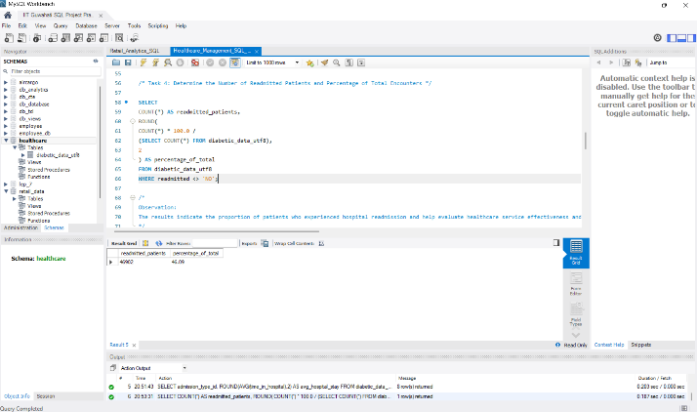
Task 5: Identify the Age Distribution of Patients
The age distribution provides insight into the demographic composition of the patient population and identifies the most represented age groups.
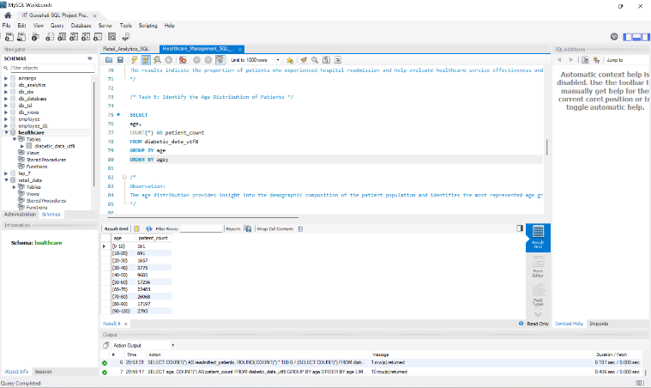
Task 6: Identify the Most Common Procedures Performed During Patient Encounters
The analysis reveals the most frequently performed procedures and highlights healthcare service utilization patterns.
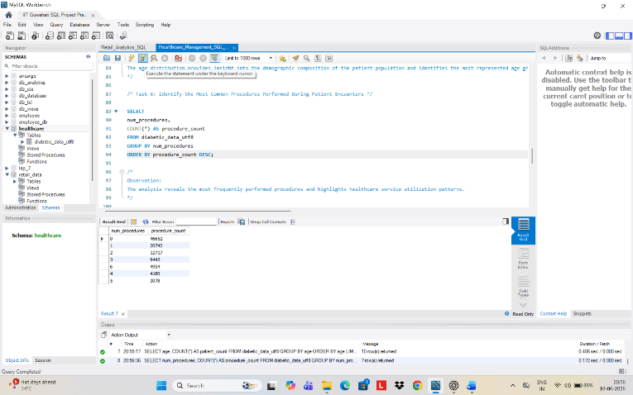
Task 7: Calculate the Average Number of Medications Prescribed for Patients in Each Age Group
Medication requirements vary across age groups, reflecting differences in treatment complexity and healthcare needs.
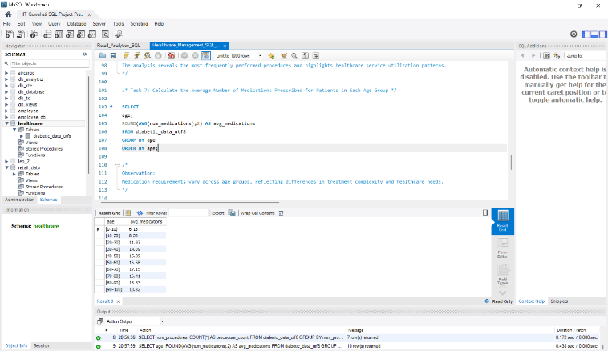
Task 8: Identify the Distribution of Readmission Rates Across Different Payer Codes
The analysis highlights variations in readmission rates across payer categories and provides insights into healthcare utilization patterns.
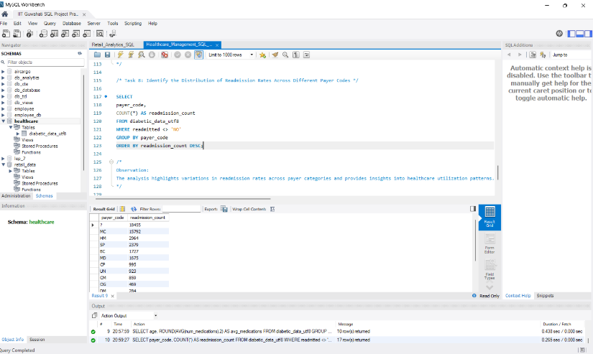
Python
The dataset contains 101,766 patient encounter records and 50 healthcare-related attributes. The dataset includes demographic information, diagnoses, medications, admission details, and readmission status, making it suitable for comprehensive healthcare analytics.
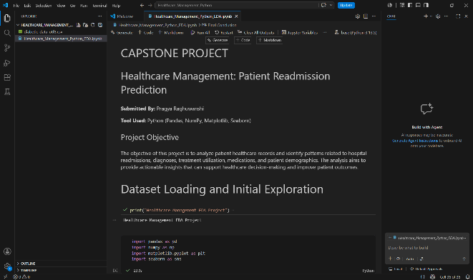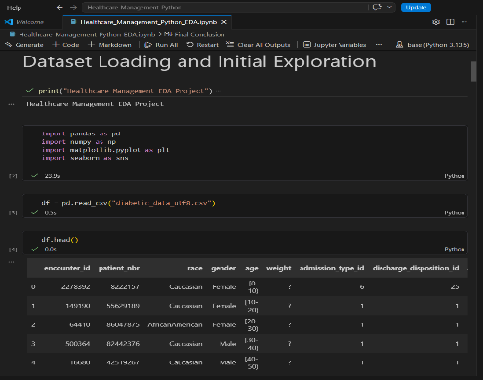
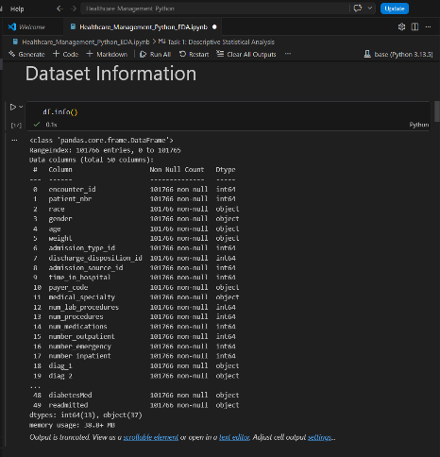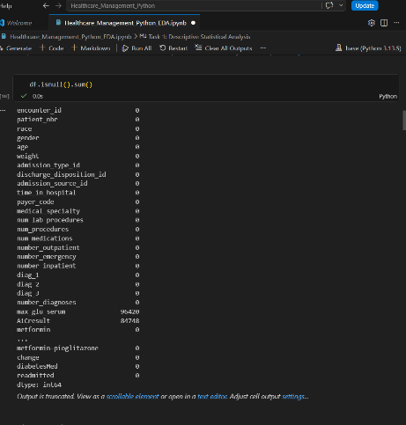
# Task 1: Descriptive Statistical Analysis
The statistical summary provides insights into hospitalization duration, laboratory procedures, medications, and diagnosis counts. The variation across these measures indicates diverse healthcare needs and treatment complexities among patients.
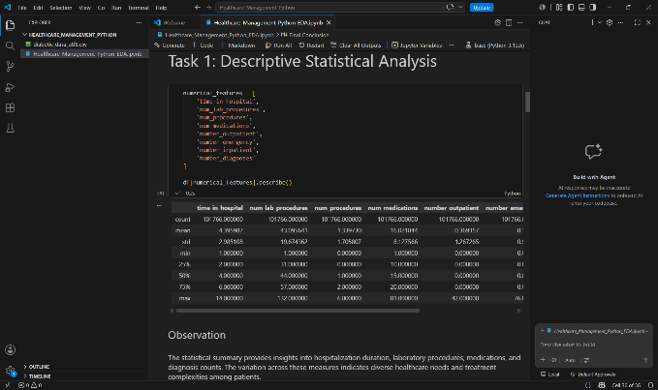
# Task 2: Distribution of Patient Race
The majority of patients belong to the Caucasian category, followed by African American patients. Other racial groups represent a comparatively smaller share of the patient population.
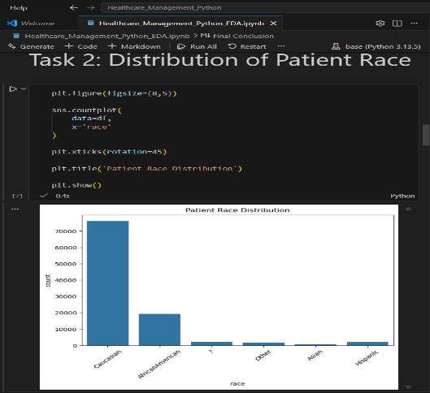
# Task 3: Distribution of Patient Gender
The dataset contains both male and female patients in substantial proportions, enabling balanced demographic analysis across genders.
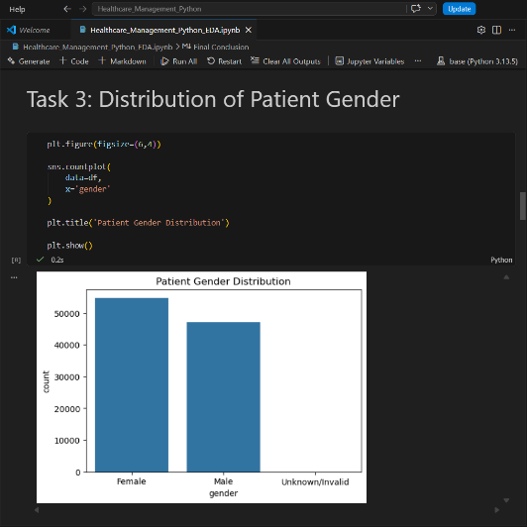
# Task 4: Relationship Between Readmission Status and Age Group
Readmission frequency generally increases in older age groups. Elderly patients appear to experience higher rates of hospital readmission compared to younger patients.
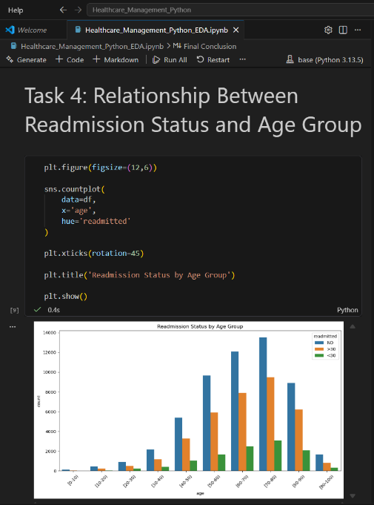
# Task 5: Correlation Analysis of Numerical Features
Most numerical variables exhibit weak to moderate correlations, suggesting that patient outcomes are influenced by multiple healthcare factors rather than a single dominant variable.
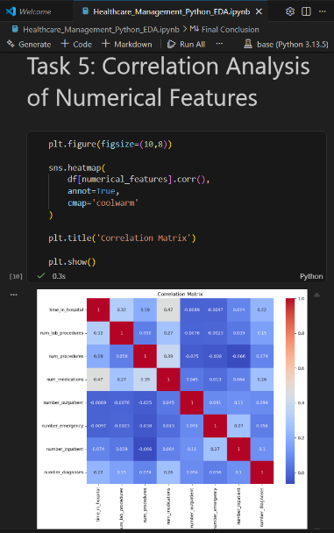
# Task 6: Analysis of Medication Changes and Total Medications
Medication changes are common among patients, and the number of medications prescribed varies significantly across patient encounters, reflecting diverse treatment requirements.
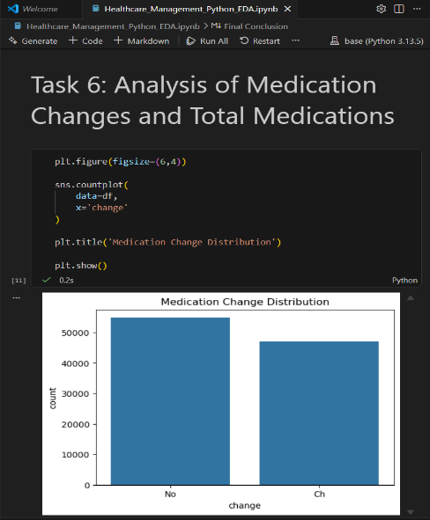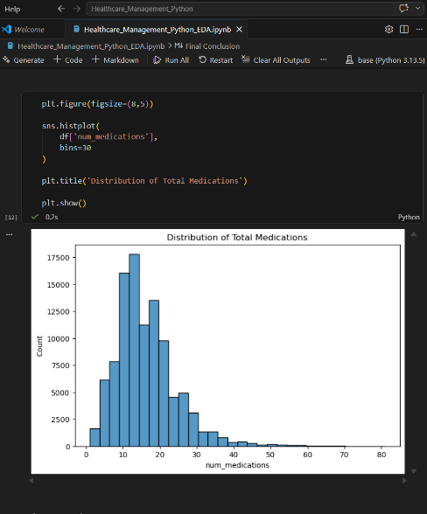

# Task 7: Distribution of Diagnosis Categories
A small number of diagnosis categories account for a large proportion of patient encounters, indicating recurring health conditions within the healthcare system.
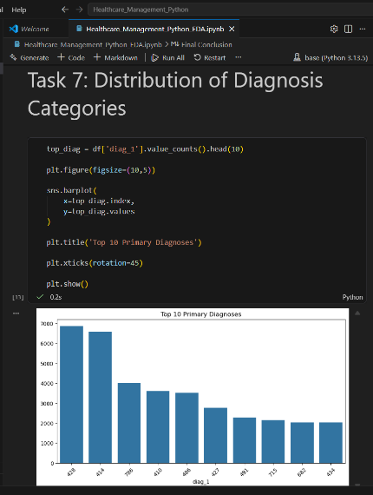
# Task 8: Admission Types, Sources and Discharge Dispositions
The distributions highlight the most common admission pathways, referral sources, and discharge outcomes among patients, providing insights into healthcare service utilization.
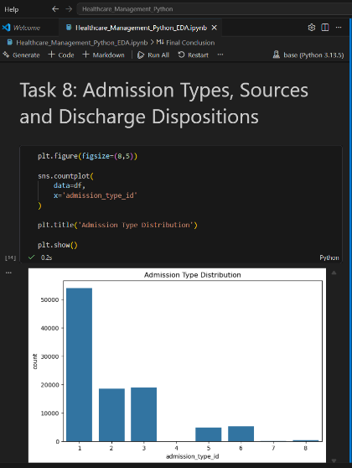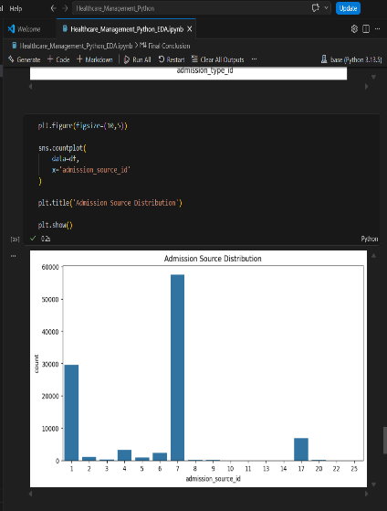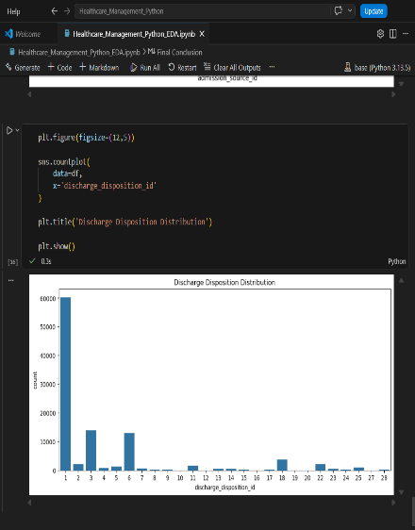

Tableau
Task1
Show distribution of readmitted counts of diagnoses and emergency cases
Patients categorized as readmitted show higher diagnosis counts and emergency visit frequencies compared to non-readmitted patients. This suggests that increased healthcare utilization may be associated with a greater likelihood of hospital readmission.
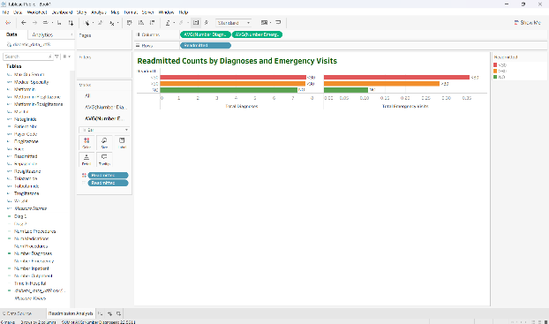
Task 2: Analyze the Distribution of Readmitted Patients Across Age Groups
Patient counts increase significantly in older age groups. Readmission rates are more prominent among patients aged above 50 years, indicating that age may be an important factor influencing hospital readmissions.
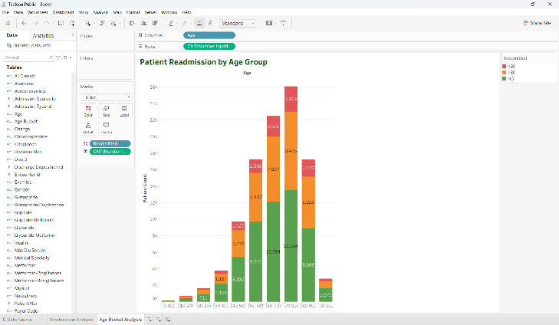

Task 3: Analyze Healthcare Utilization by Readmission Status
Patients who were readmitted exhibit higher average medication usage, diagnosis counts, emergency visits, and hospital stay durations compared to non-readmitted patients. This indicates that patients requiring greater healthcare utilization are more likely to experience hospital readmission.
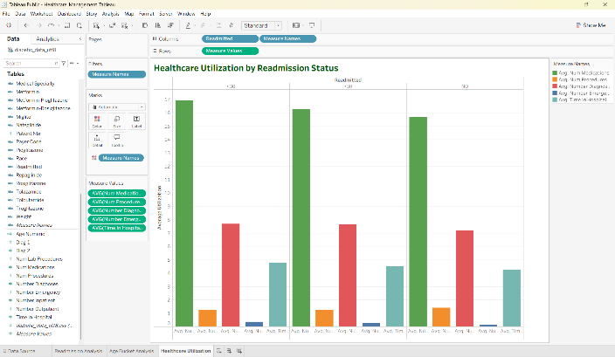
Task 4: Analyze the Relationship Between Medications, Lab Procedures and Diagnoses
Patients with higher medication usage and laboratory procedure counts tend to have larger diagnosis counts. Non-readmitted patients represent the largest patient group; however, readmitted patients also exhibit significant treatment complexity, suggesting that extensive healthcare utilization may contribute to hospital readmission risk.
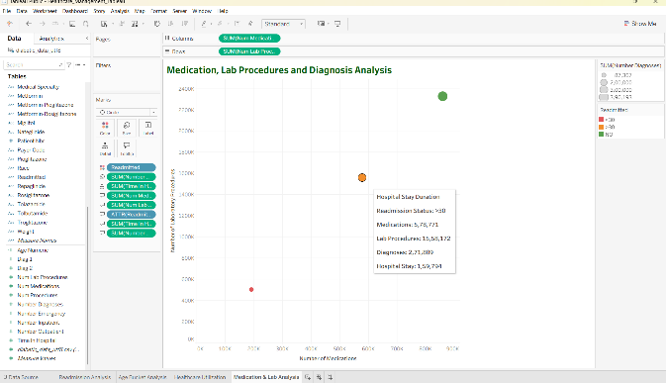
Dashboard
Healthcare Management Dashboard
The dashboard highlights key patient readmission patterns and healthcare utilization trends. Results indicate that older patients and those with higher medication usage, diagnoses, laboratory procedures, and hospital stays are more likely to experience readmission. These insights can help healthcare providers identify high-risk patients and improve care outcomes.
